**How to run the Matlab grouping code?**

From Jeremy’s email:

This is the current Matlab code.  I believe it is self contained.  It needs two spreadsheets - which are direct exports from PaveM.  One is the list of segments (Roadway > Database > PaveM Management Sections) and the other is the results from a scenario.  I've not run this with new results for a little while, so there might be some column name changes that need to be handled.

Regards,

  -Jeremy

You need to change two line to load the input files. The line numbers may vary.

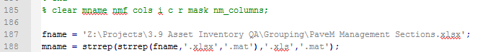



**Where to find information about the database?**

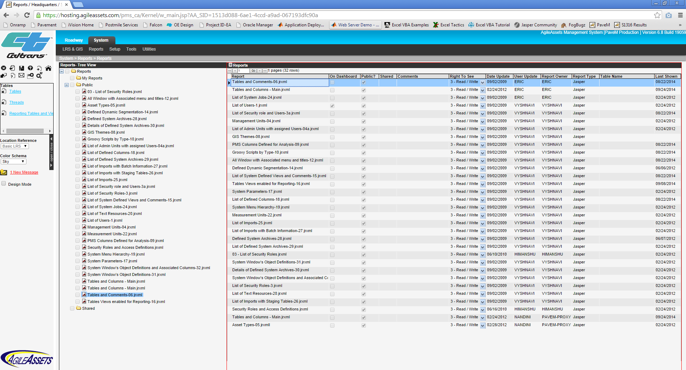

You can look up info about the database after generating reports.

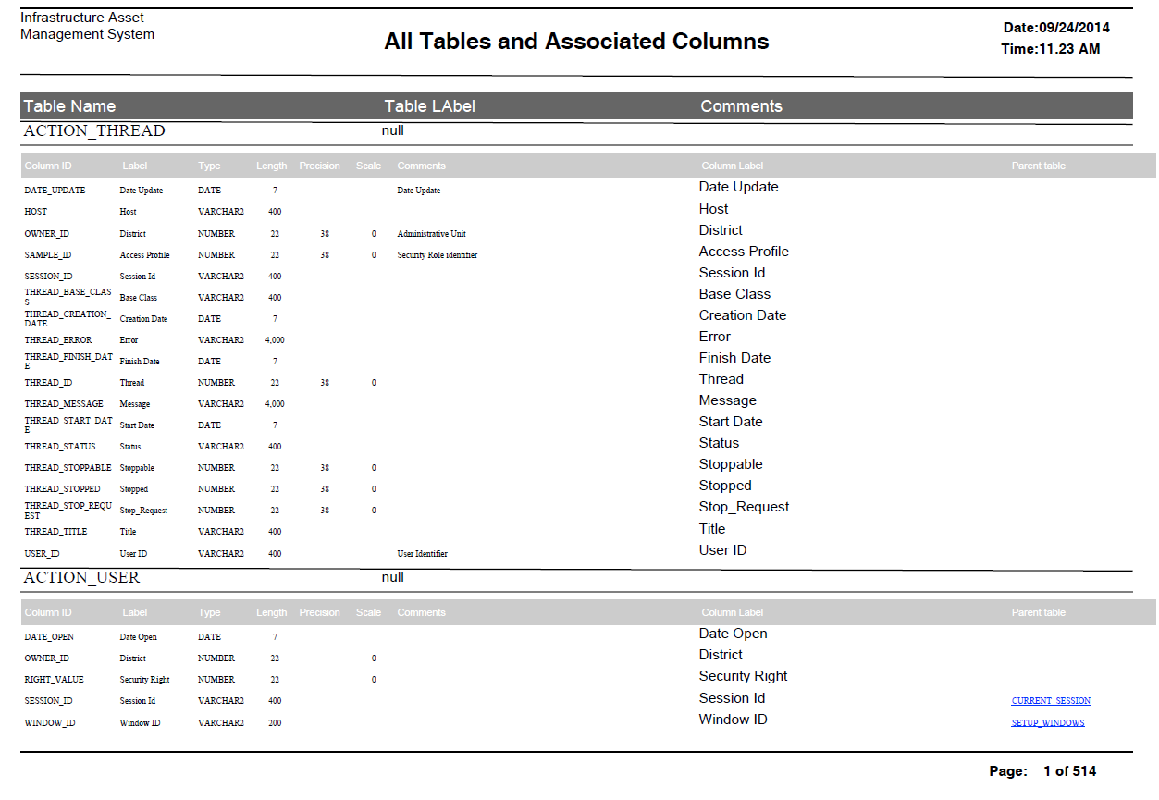

**Manual for Jasper iReport:**

<http://jasperreports.sourceforge.net/JasperReports-Ultimate-Guide-3.pdf>

Youtube has a lot of tutorial videos. It is better to watch ALL first. Caltrans use Jasper iReport 4.0.0.



**How to run the Route History Diagram?**

There are five files in total.

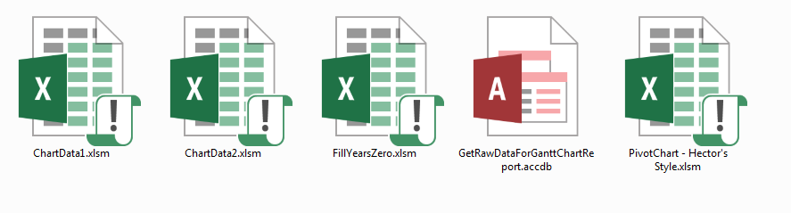

**The hotkey is for the last step. Doesn’t make any sense?**

**There is an instructional video for it. In the following folder:**

**K:\02 Pavement Management and Performance - TAP\PMS\11-Student's Documents\Jing_Zhao\Don't Move Please**

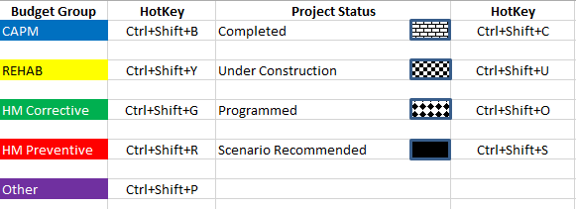

**Legend for chart report.**



**Queries for combining 3 tables within Access:**

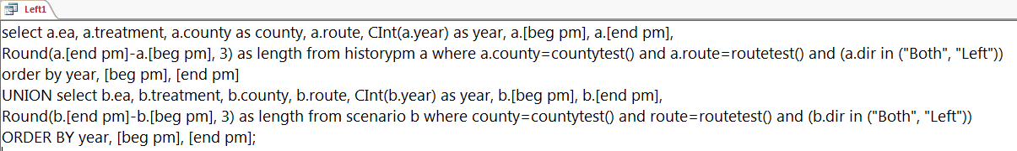

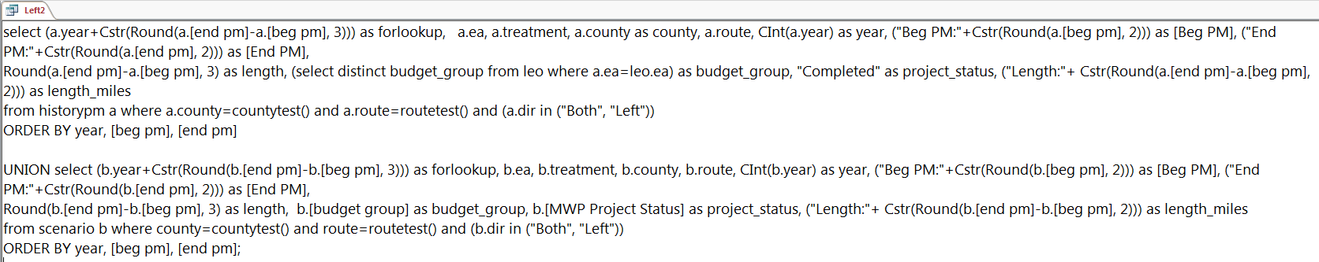

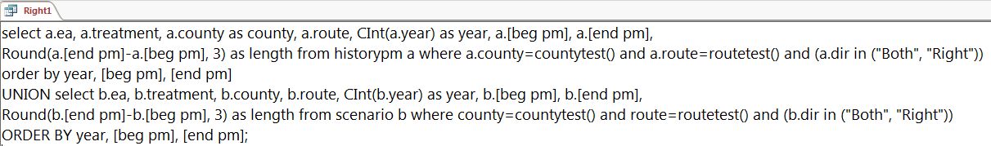

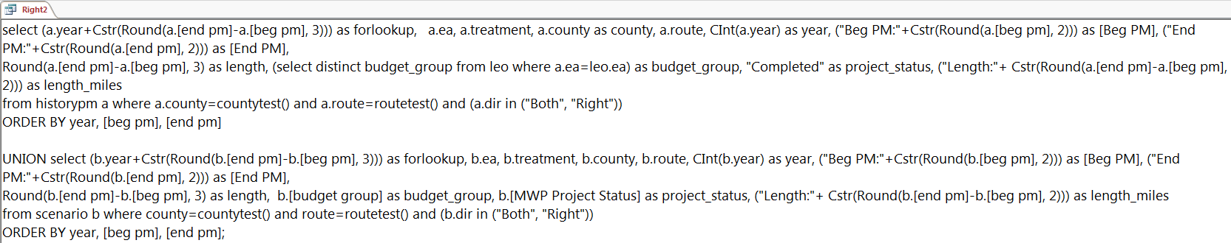

**Macro to generate the raw data spreadsheet within Access:**

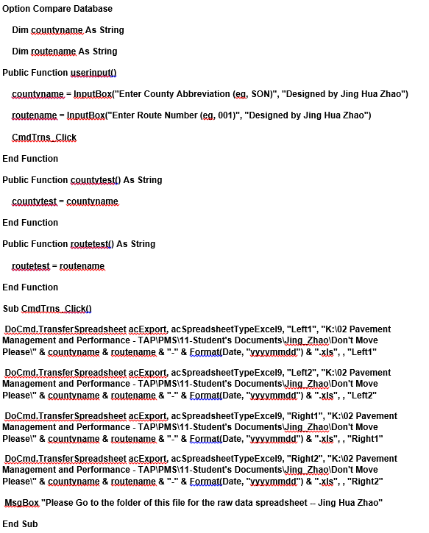

**The formulas in ChartData1:**

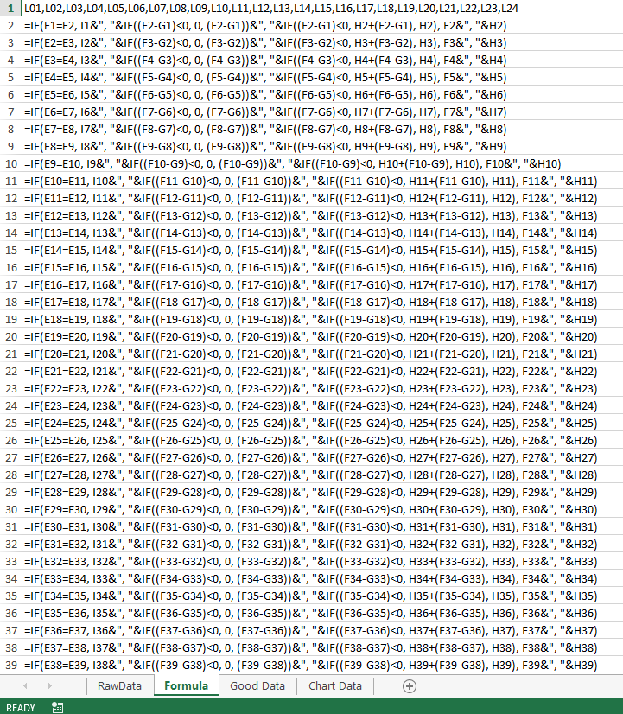

**The formulas in ChartData2:**

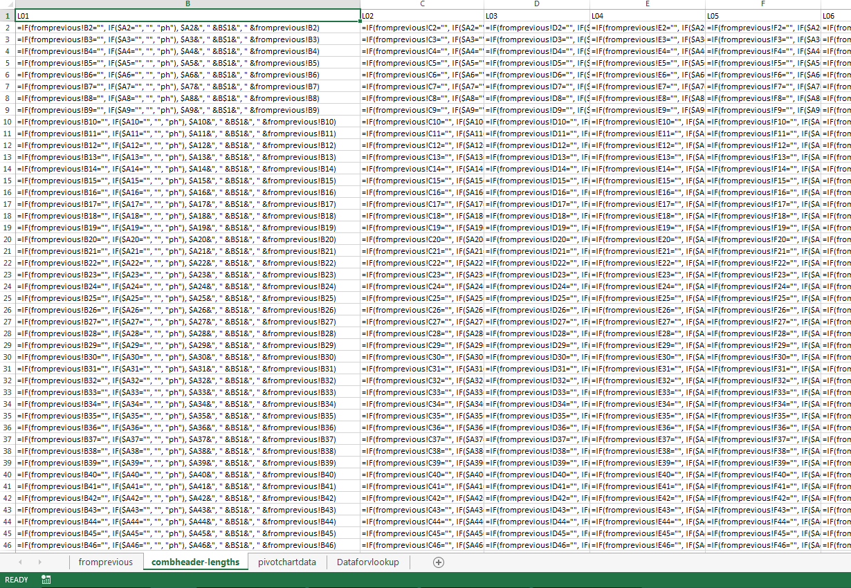

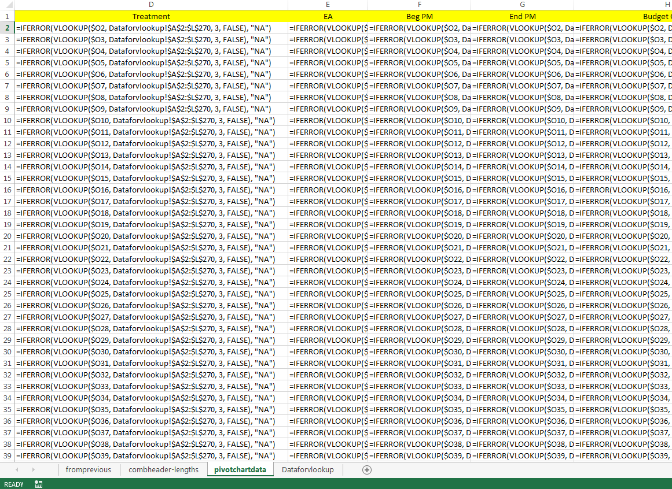

**The formulas in FillYearZero:**

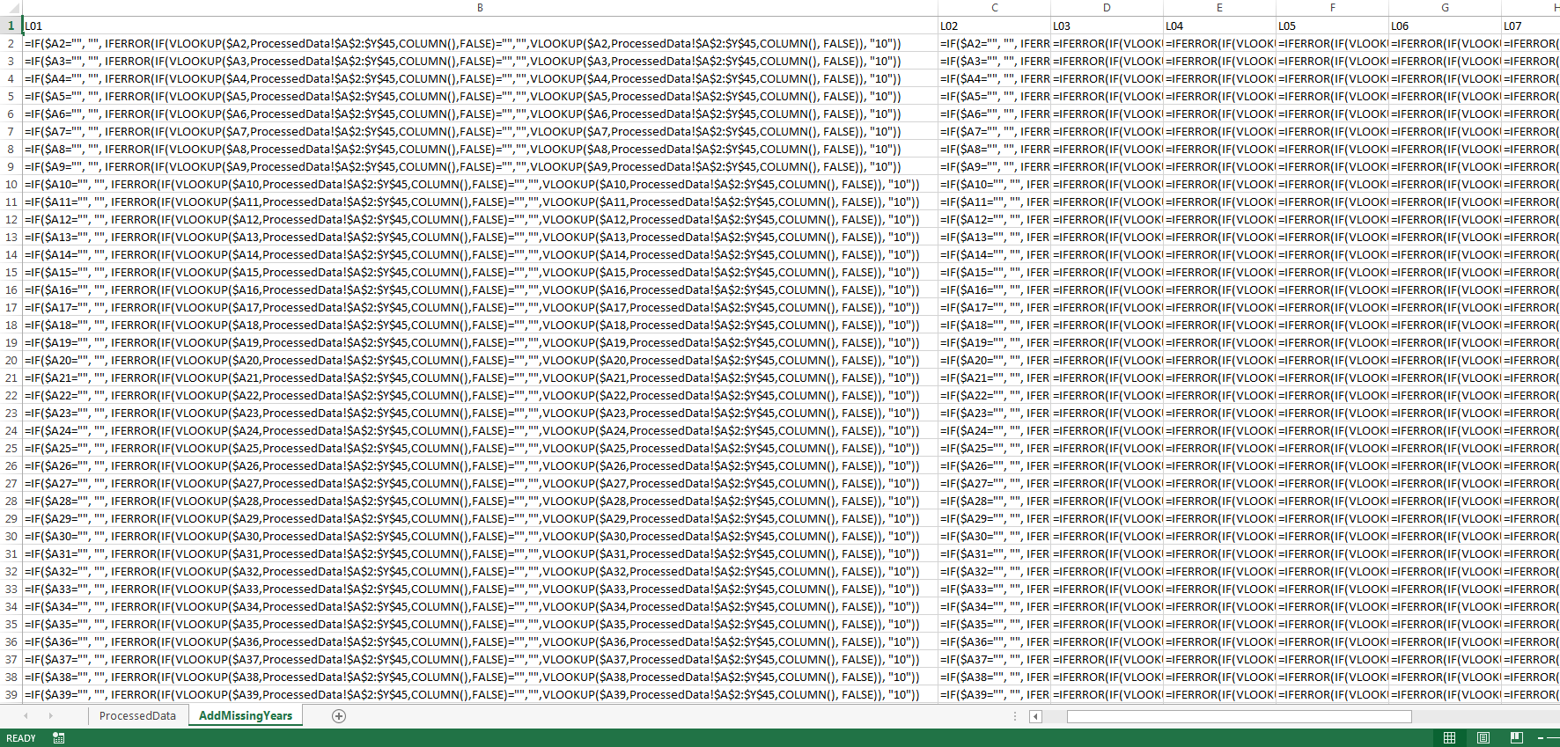

**The macro to generate the raw diagram:**

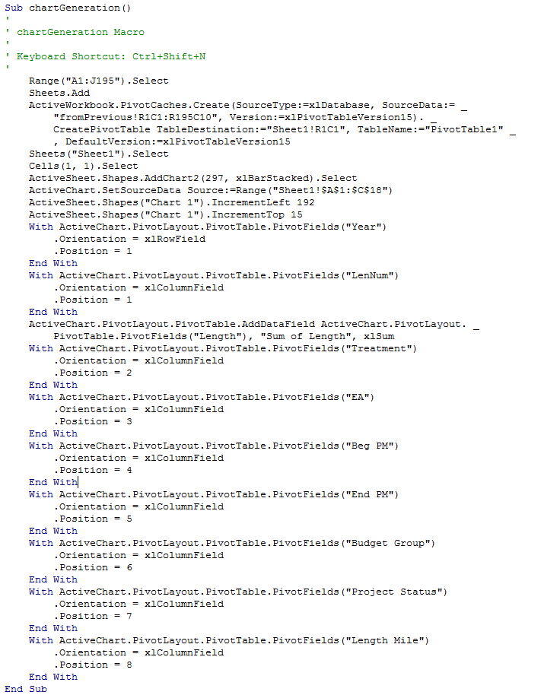

**The macro to style the raw diagram:**

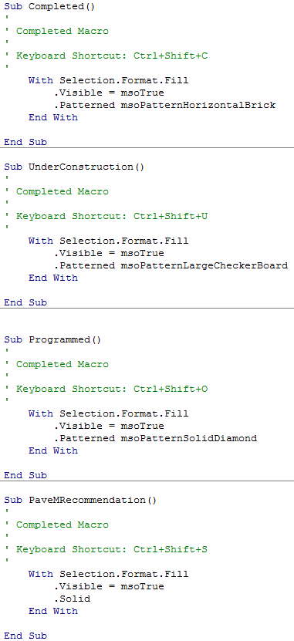

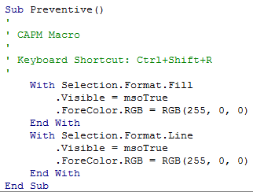

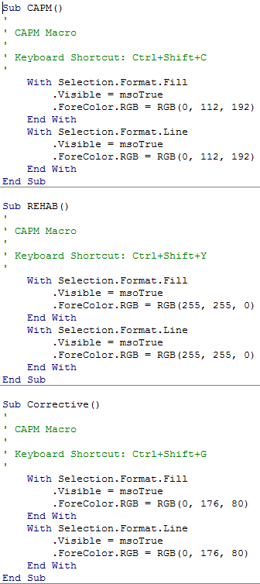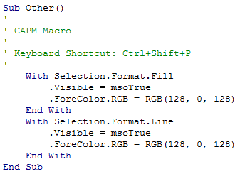

**The macro in ChartData1:**

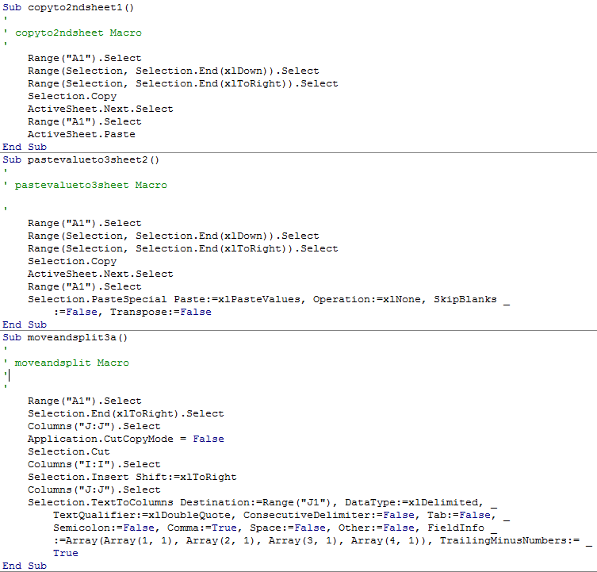

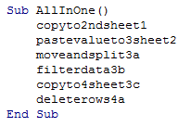

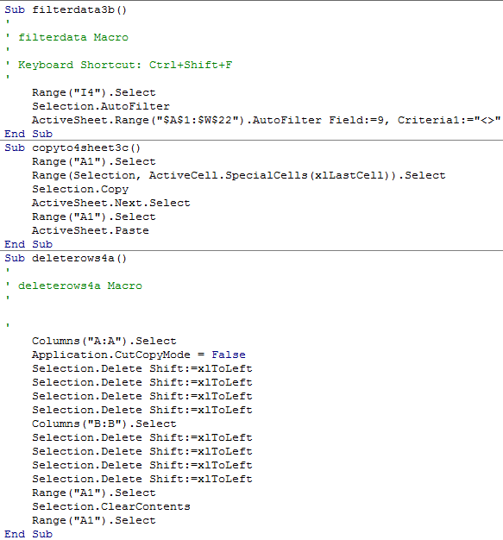 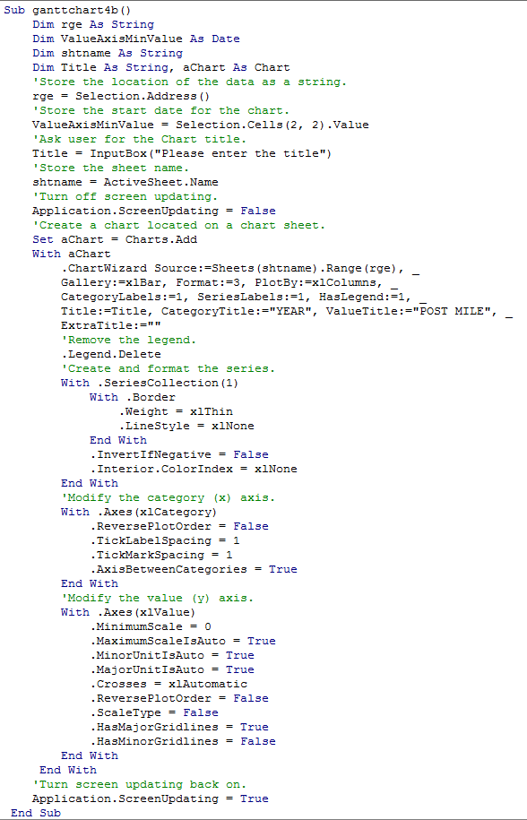

**The macro in ChartData2:**

